**Types of computer**

**Analog Computer**

**Digital Computer**

**Hybrid Computer**

**Analog computer**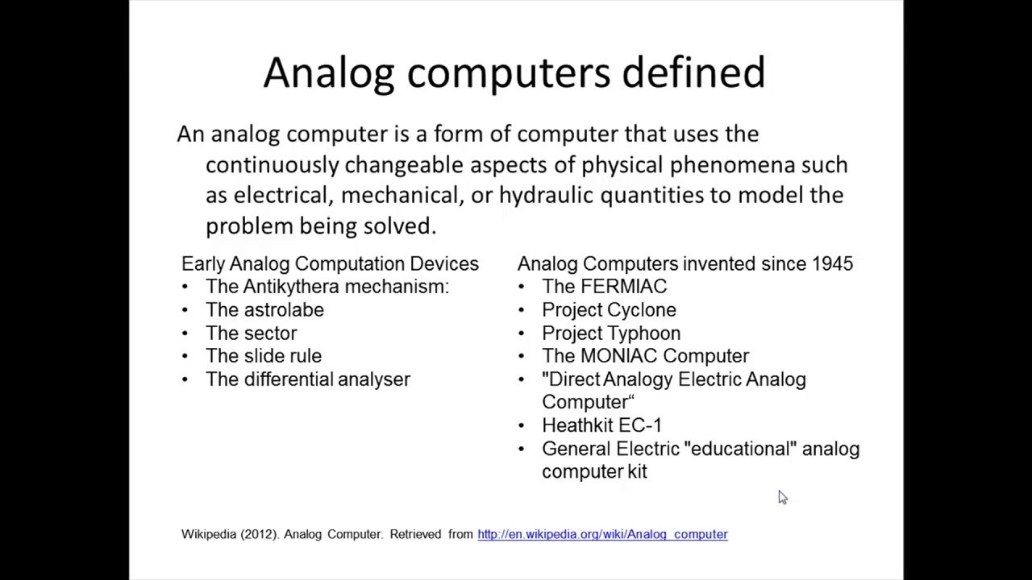

**Amna azam**

**1st professional**

